**Project Design Phase-II**

**Technology Stack (Architecture & Stack)**

|  |  |
| --- | --- |
| Date | 13 March 2025 |
| Team ID |  |
| Project Name | Power BI Inflation Analysis: Journeying Through Global Economic Terrain |
| Maximum Marks | 4 Marks |

**Technical Architecture:**

This document outlines the technology stack used for the Power BI Inflation Analysis project. The system is built on Power BI Desktop and follows a structured data workflow from raw dataset ingestion to visualization and reporting. The entire process is conducted offline, without cloud deployment.

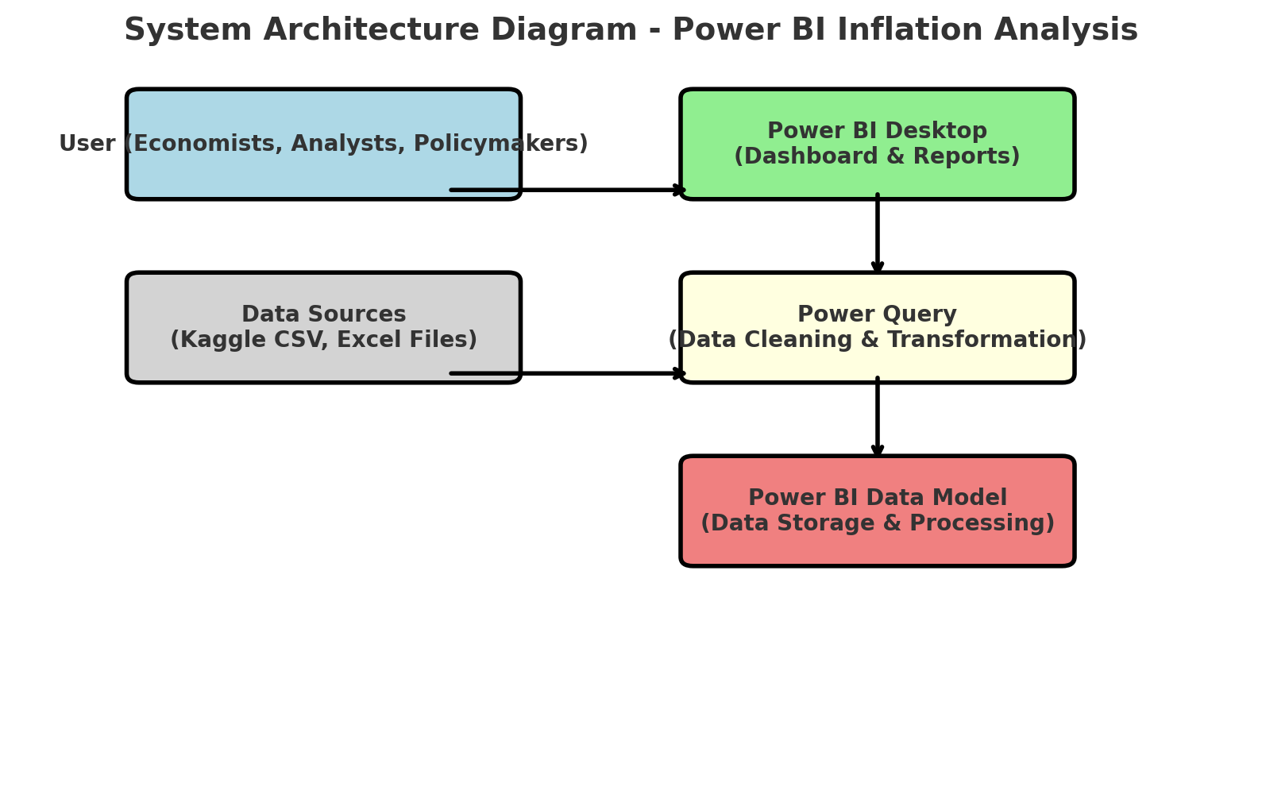

**Table-1 : Components & Technologies:**

|  |  |  |  |
| --- | --- | --- | --- |
| **S.No** | **Component** | **Description** | **Technology** |
|  | User Interface | Power BI Desktop | Allows users to interact with dashboards and reports. |
|  | Data Import | CSV/Excel Files (Kaggle Dataset) | Provides raw inflation data for analysis. |
|  | Data Processing | Power Query (M Language) | Cleans, transforms, and prepares data. |
|  | Data Storage | Power BI Data Model | Stores structured data for visualization. |
|  | Visualization | Power BI Charts & Reports | Generates insights through graphs and tables. |
|  | Interactivity | Power BI Slicers & Filters | Enables users to explore data dynamically. |
|  | Export & Sharing | Power BI PDF, PPT | Allows sharing of reports in standard formats. |

**Table-2: Application Characteristics:**

| **S.No** | **Characteristics** | **Description** | **Technology** |
| --- | --- | --- | --- |
|  | Open-Source Frameworks | Power BI uses open-source connectors for data import. | Power Query, DAX |
|  | Security Implementations | Local access control and dataset encryption. | Role-Based Access Control (RBAC) |
|  | Scalable Architecture | Handles large datasets with optimized queries. | Power BI Data Model |
|  | Availability | Works offline with Power BI Desktop, ensuring constant access. | Local Deployment |
|  | Performance | Optimized using DAX calculations and indexing. | Power BI Engine |